Online Surveys
If you carry out a survey on paper then you have to first get the survey to your target group, then you have to collect it in again, then you probably have to enter all the information into a computer – all before you can start to see the messages emerging from your questions.

With an online survey, your target group can fill in answers on screen and you then you can easily download the data, or view a summary of survey responses and data online.

There are many free and low cost online survey tools that step you through each stage of creating, promoting and analyzing the results from a survey.
Getting Started

1) Create an account – visit www.surveygizmo.com and look for the link to .

2) Your first survey – once you are logged in, choose  to get started and edit your first survey. Use the links to ‘add questions’ to your survey.

You will need to select the type of question you want to ask, enter the question itself, and select any options for the way those taking the survey can reply.

Add as many question as you need. You can split questions on pages. Keep in mind how long it will take to complete the survey and cut back on questions if you think it could take too long.

3) Publishing and promoting your survey – when you are happy with all the questions you have added you can set up the ‘look and feel’ of your survey from the ‘edit’ tab of SurveyGizmo and then use the ‘Publish’ tab to make your survey public and open for responses.

Circulate the link to the survey widely (make sure you use the option to create a readable link).

4) Explore and analyse the results – when your survey is over (or at any time) you can use the ‘Reports’ tab in SurveyGizmo to generate reports.

Choose from the available report types and then view your report or download the data to look at it further.
Practical Participation offer training & consultancy in using social media tools and strategies in participation projects.
This series of Getting Started guides are designed to offer a flavour of the tools available.

Version 0.1 – December 2007
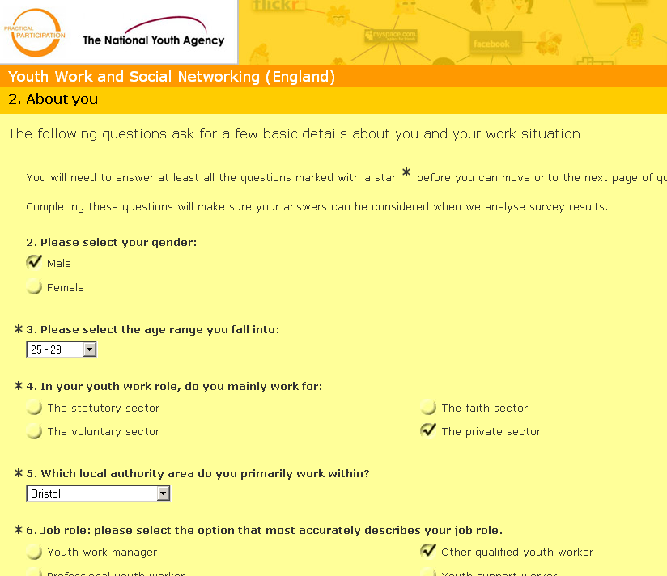



With SurveyGizmo.com
Top tips

Most online survey tools are free up to a certain number of responses after which you either need to upgrade to a paid account, or pay-per-response. Expect to pay from £100 yr to £100 month for a tool that allows unlimited responses.

You can enter information you gather from paper surveys into most online survey systems, so you don’t just have to run your survey online.

You can run an online survey for a short amount of time, or use it as an ongoing feedback and quality control tool.
An alternative to SurveyGizmo.com is SurveyMonkey,com

